hile Command/While Loop

* Copy and run the code below.

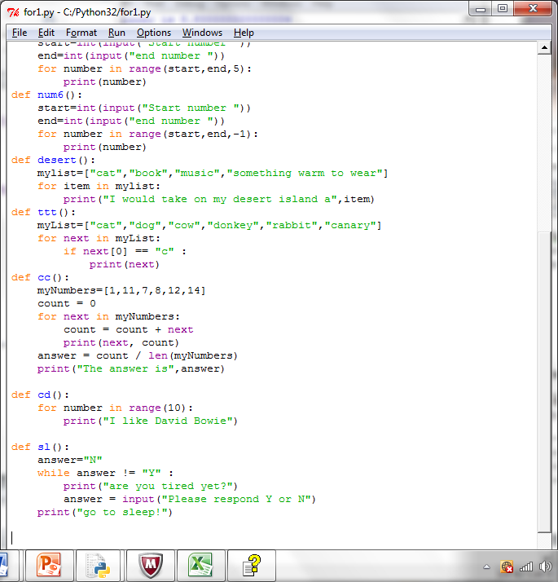

* What does the while command do?

|  |
| --- |
| If the answer is still Y it’ll keep asking the question. |

* What is the condition that is being tested and how does it change?

|  |
| --- |
| It’ll keep looping until it receives the answer Y. |

* What will happen if the input is "Y"?

|  |
| --- |
| It’ll tell you to go to sleep. |

* What will happen if the input is "No"?

|  |
| --- |
| It will continue asking if you are tired. |

**Activity 13.2**

Write a program that asks the user if they are hungry. While they reply ‘N’ the program repeats the question. Each time it repeats the question, it will count and show how many times they have replied ‘N’.

When they reply ‘Y’, the program tells them to get something to eat.

|  |
| --- |
| count = -1  answer="Y"  while answer != "N" :  print("are you hungry?")  answer = input("Please respond Y or N")  count = count + 1  print("get something to eat!")  print(count) |

**Activity 13.3**

* Copy and run the code below.

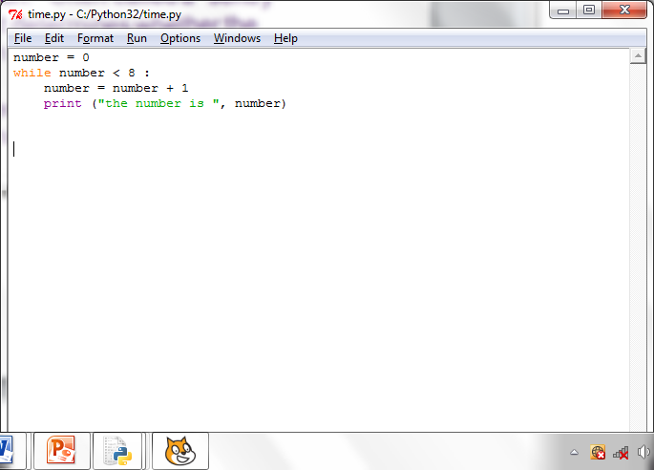

* What does this program do?

|  |
| --- |
| It adds every number starting from 0 to 7 by one. |

* Look up the definition of a "sentry" or "sentinel" variable. What does this mean?

|  |
| --- |
| A sentry variable is a variable used in the condition. (it can also be called the loop or sentinel variable). |

* Looking at the code, what is the ‘sentry’/sentinel variable?

|  |
| --- |
| Number. |

* What is the condition?

|  |
| --- |
| While. |

**Activity 13.4**

**Flowcharts and while command**

Flowcharts can be used to represent programs. Complete the flow chart for this program.

Are you tired?

start

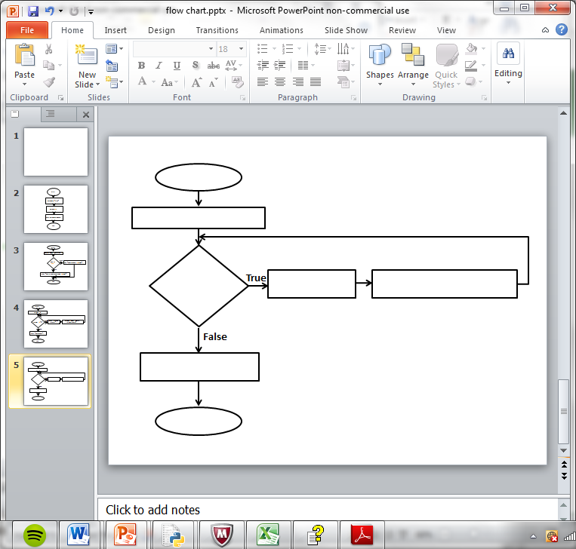

N (No) or Y (Yes)

end

You answer N

Go to sleep

Repeat ‘are you tired?